Result 1

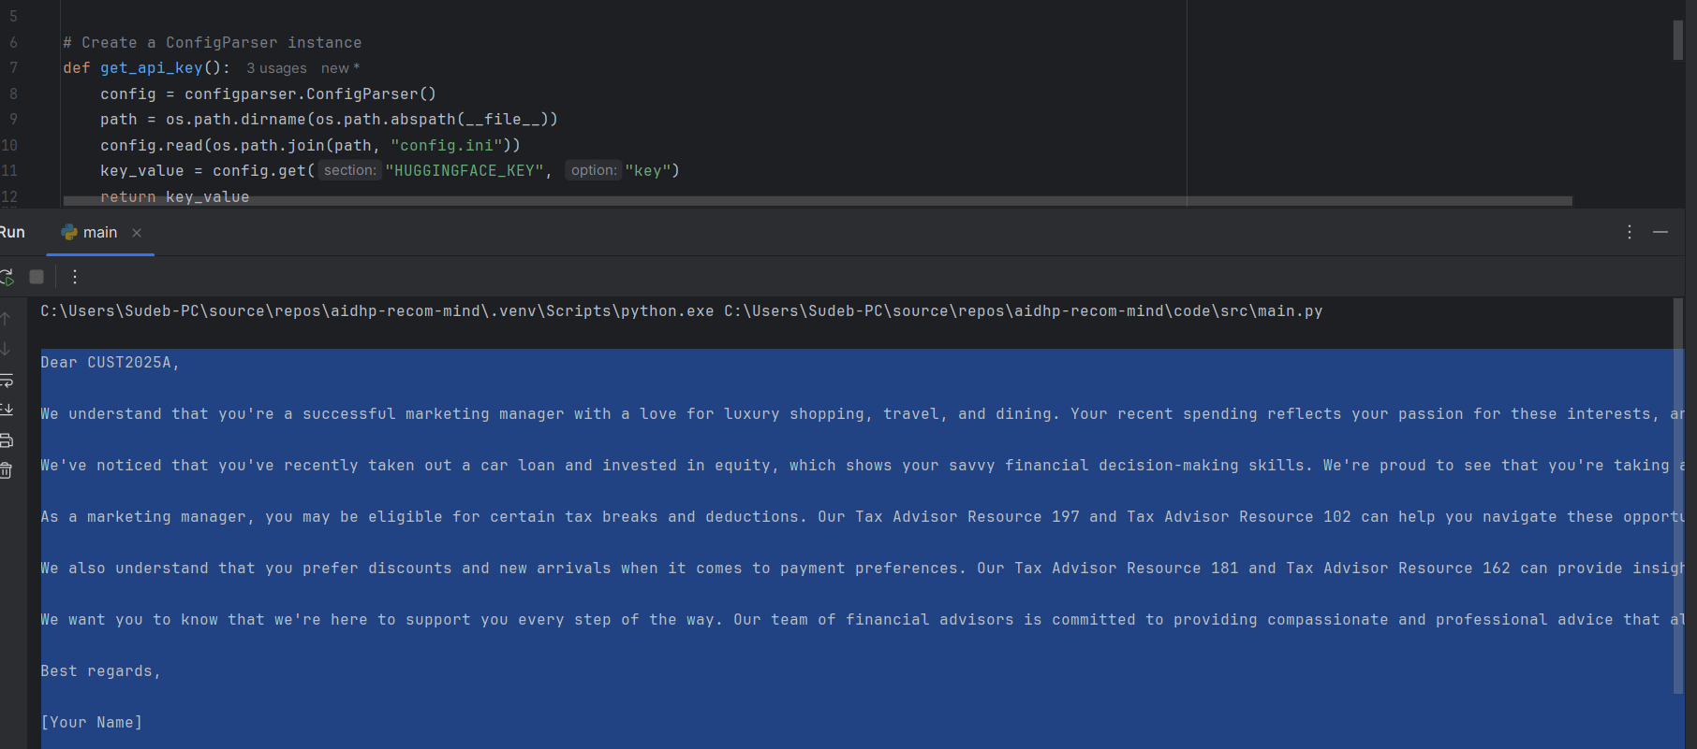

Result2:

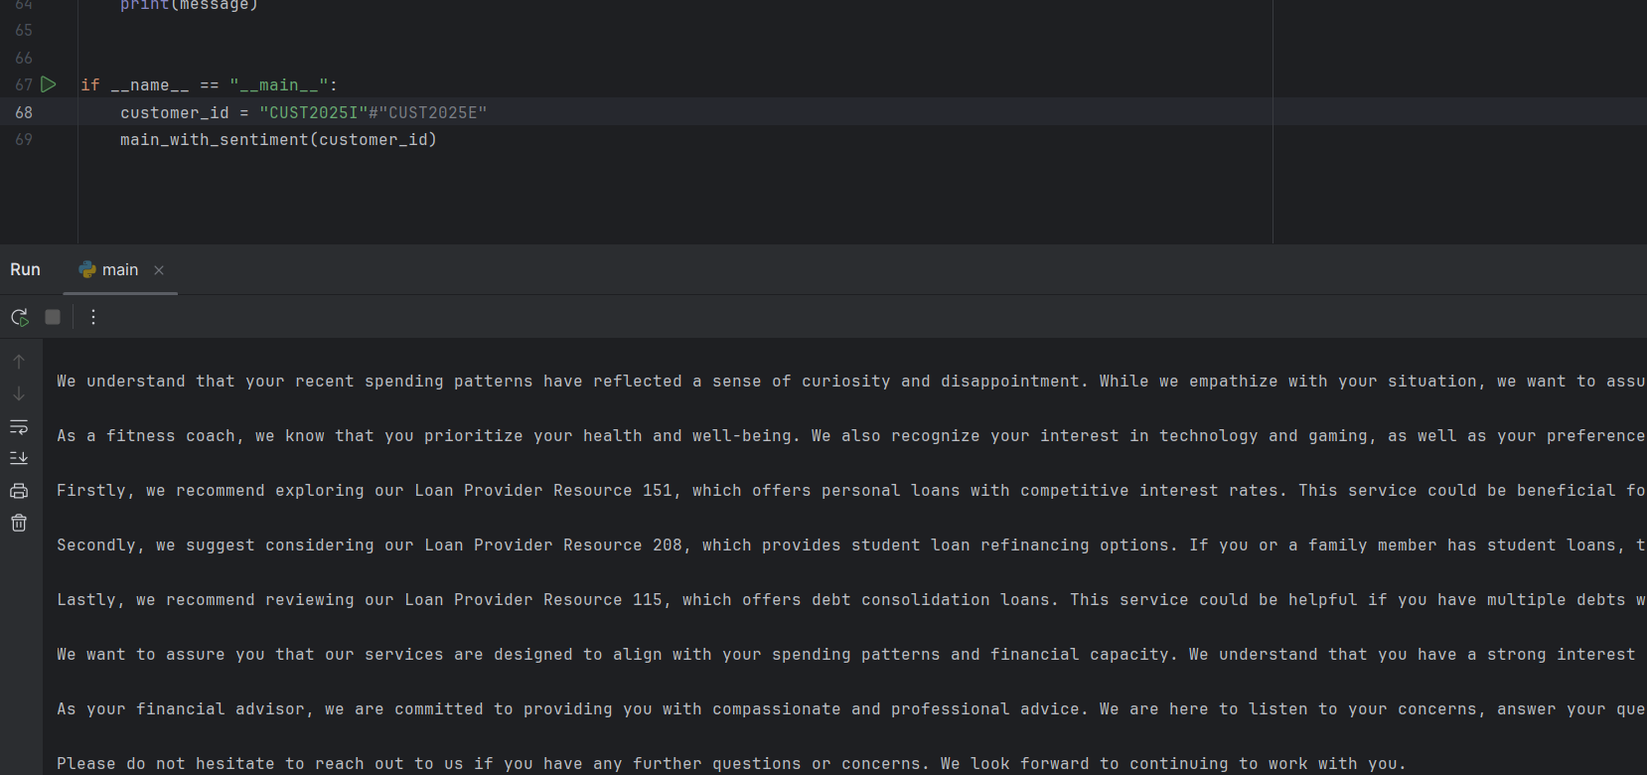

**Instructions:**

1. expand the codebase zip and keep under code/src .. we are using python 3.10

2. requirements.txt provided install using pip

3. main.py is the driving script run the same to get result. change the customer_id in main to get different result for different customer ids

4. adjust the imports in each dependency python scripts based on the reference root directory on your ide

5. for individually testing if each scripts are working main is setup in each files. use those.

**## Troubleshooting**

- If dependencies fail to install, check `requirements.txt` for compatibility with Python 3.10.

- If imports fail, verify the module paths and adjust the project root settings in your IDE.

- If `ModuleNotFoundError` occurs, ensure the script is executed from the correct project directory.

**Huggingface api key token:**

1. Login to <https://huggingface.co/>
2. 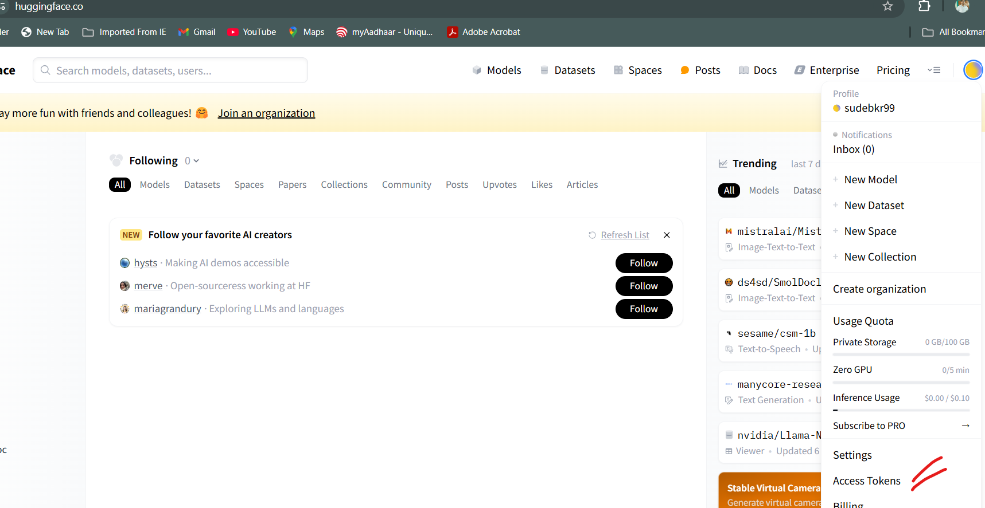
3. 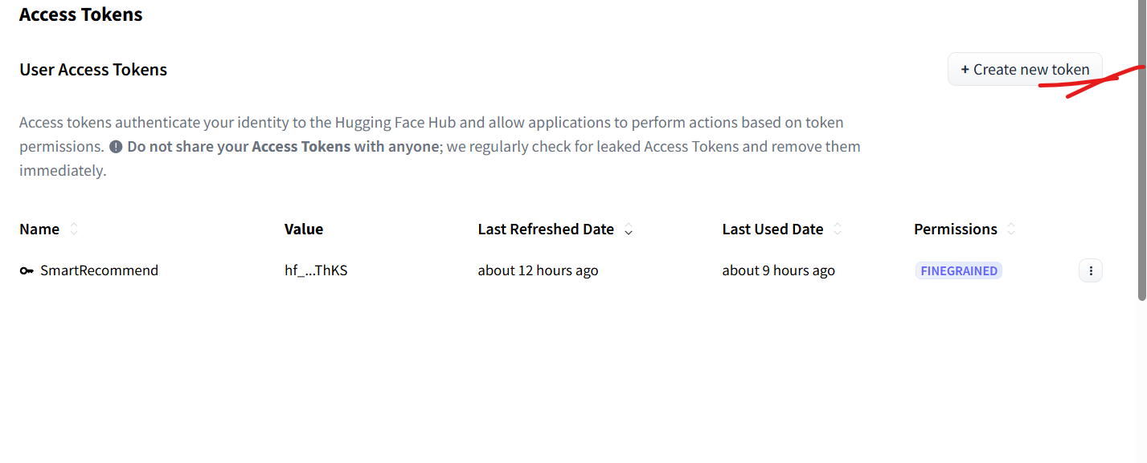
4. 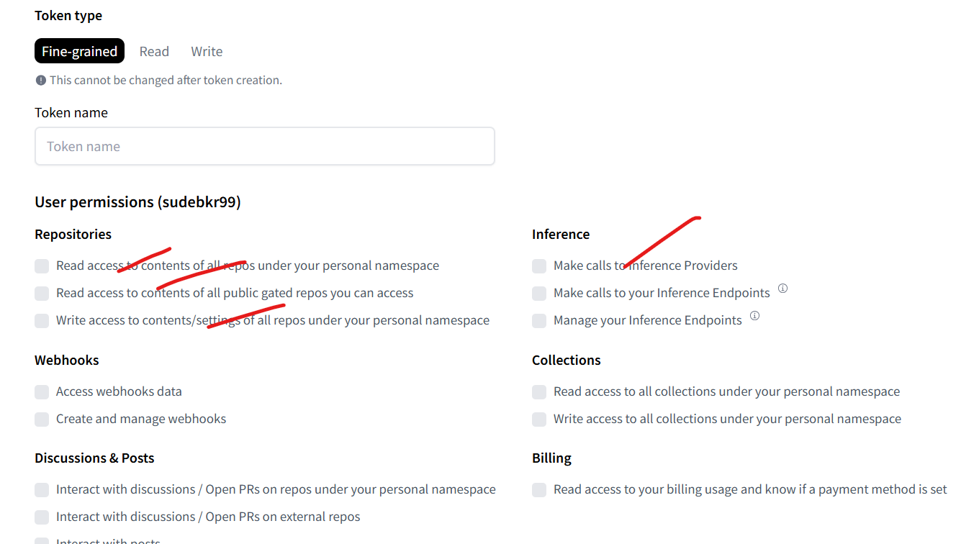

**Next steps:**

1. Fix the code for organization customers. There is out of bounds error coming up currently. Probably in the matching stage. Need to handle that. Should be minor fix
2. Create an ui page that should have user based login with the customer id.
3. From ui, we should be able to call the main function which is printing the response by analyzing the spending and sentiments and profile of customer. THIS IS PUSH MESSAGE and occurs.
4. Create another page for the chat if possible with feedback loop for relearning.
5. We need to create a ppt with the design first 🡪 the excel sheets are considered our database here.
   1. Essential ones are
      1. Customer profile individual
      2. Organization profile
      3. Sentiment data
      4. Spending history
      5. Services offered in separate excel
   2. These data are sourced from several heterogeneous sources with data pipeline. Future scope
   3. Everytime push notification to be sent, data is read from excels so if ther eis change in excel, updated data is considered
   4. Current design, I will explain on call for the models used and analysis and matches done
6. We need to create video demo and readme doc.